Nguyễn Hồ Trường Tam_1150080156_QLDA_BTTuan10
- Ganttpro
Link: https://app.ganttpro.com/shared/token/b4bd5d404d91e679a904e913f65628dc27eab1eefde7a2f690a5941e01e8b859/2035182
Bảng phân rã công việc
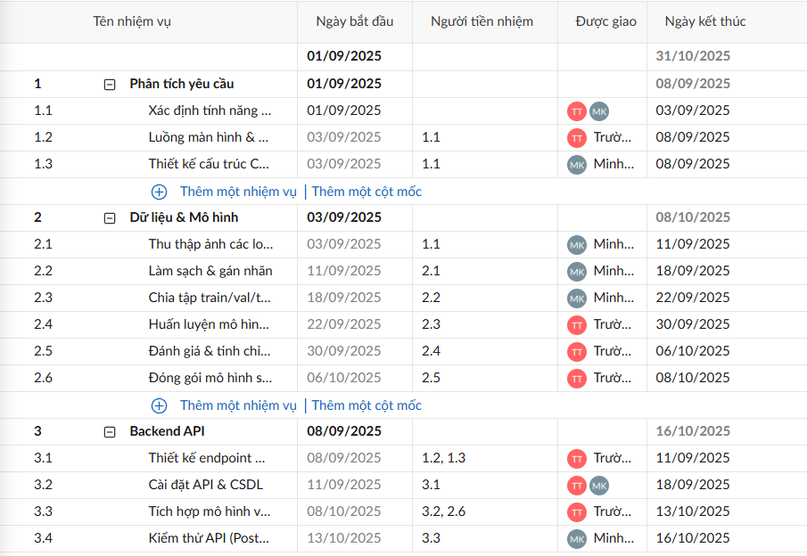
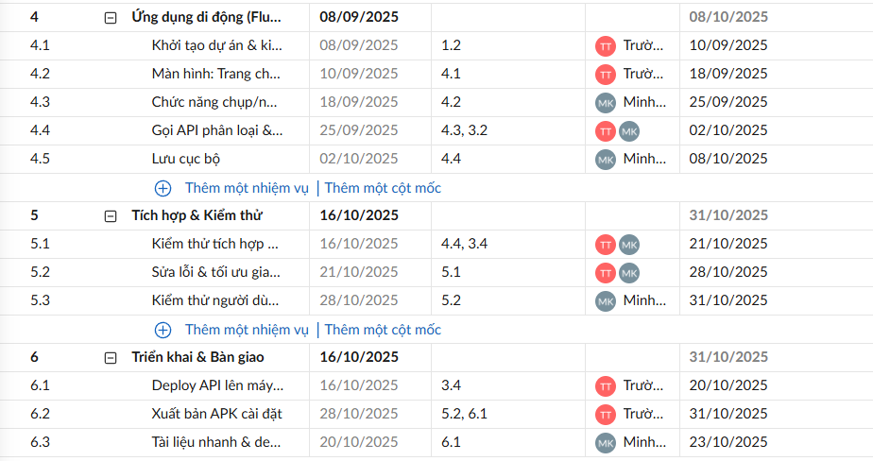
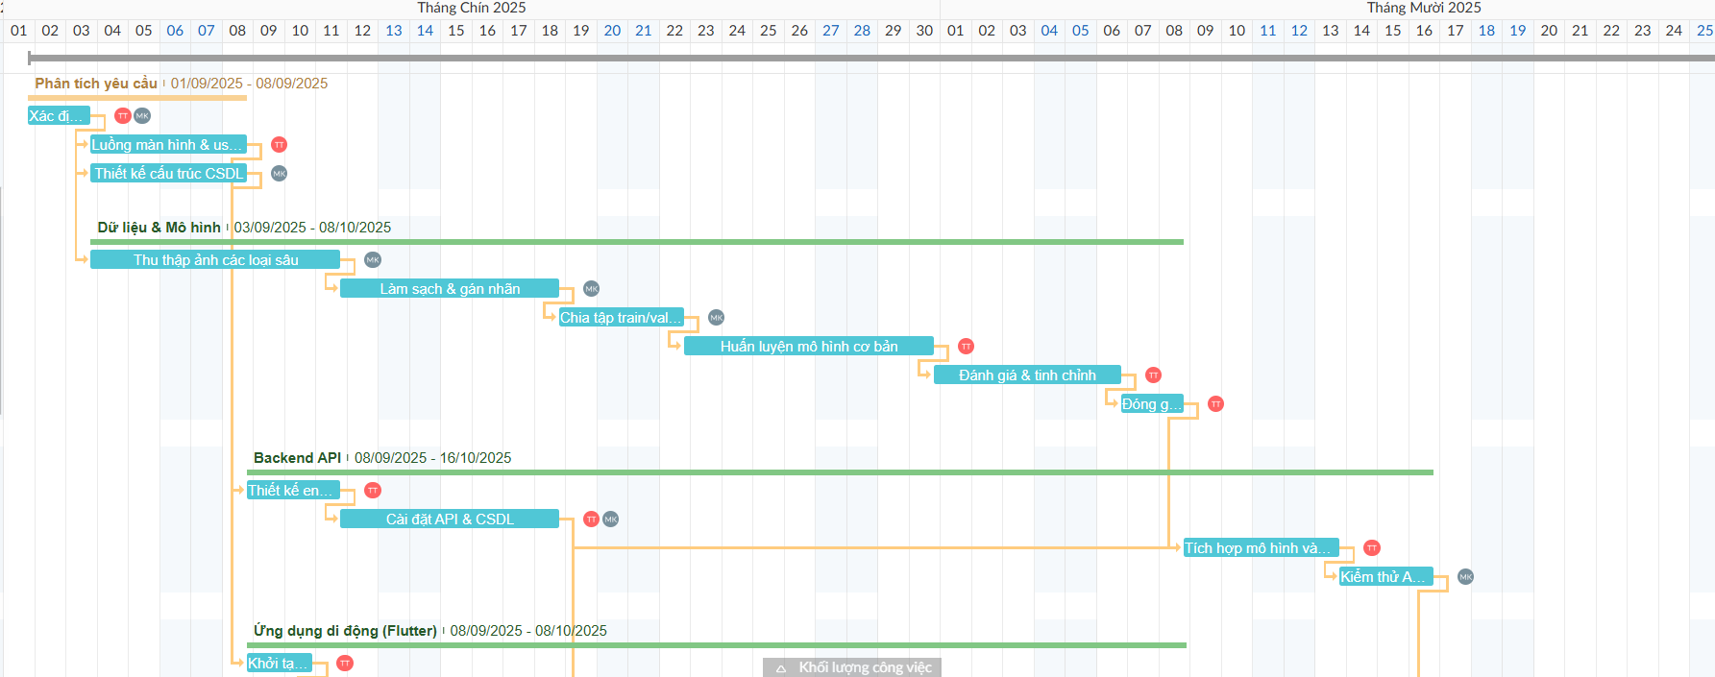
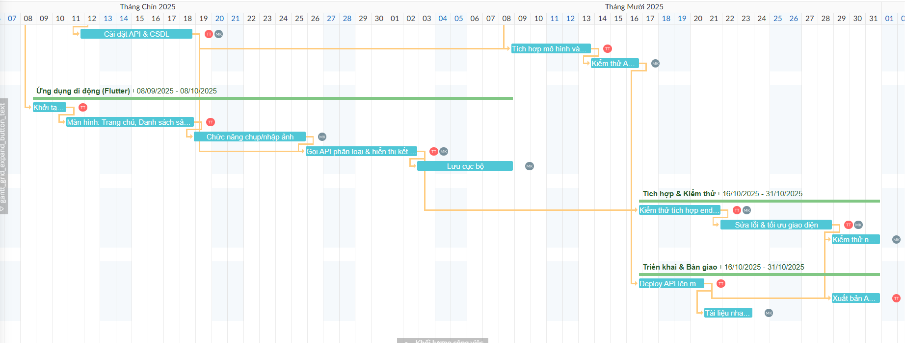
- wrike
